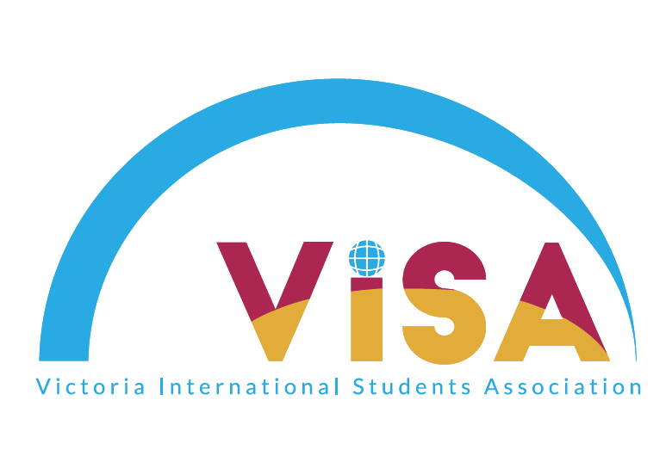

Victoria International Students’ Association (VISA)
Executive Application 2017-2018

Please complete the form and send it to vicu.visa@gmail.com by 11:59PM, Friday, March 31th:

Name:

Year:

Phone number:

Preferred Positions – Please specify 2 positions you are interested in.
(Vice President, Financial Manager, Social Events Director, Mentorship Coordinator/Intern, Multi-Media Manager, Secretary):

Share us your vision of VISA! What kind of group would you like VISA to be? What do you want to achieve as an individual in VISA? (200 words maximum):

What kind of changes can you bring to improve VISA? (200 words maximum):

Describe the qualities, skills, and experience that make you a strong candidate for your preferred position(s). (300 words maximum):

